Report
IBM HR Attrition Analysis
Name: Anushka Pokhriyal
Objective
- The goal of this project is to study employee attrition and find the major factors that may lead employees to leave the company. The project combines Python for cleaning and analysis, SQL for querying the data, and Power BI for visualization.
Tools Used
- Python for data cleaning, preprocessing, and exploratory analysis.
- SQL for filtering, grouping, and calculating attrition metrics.
- Power BI for building the dashboard and presenting insights visually
Dataset
- The project uses the IBM HR w/more Rows (Kaggle), which is commonly used in HR analytics practice projects. This dataset is generally treated as a small sample dataset for attrition analysis, not a real company-wide headcount file.
Python Work
- In the Python part, the data is cleaned, duplicate rows are checked, and important columns are prepared for analysis. Numeric fields such as JobInvolvement and WorkLifeBalance can be converted into readable labels so the results are easier to understand in charts. Python is also useful for producing summary tables and checking whether the data has any missing or repeated values.
- Data Cleaning
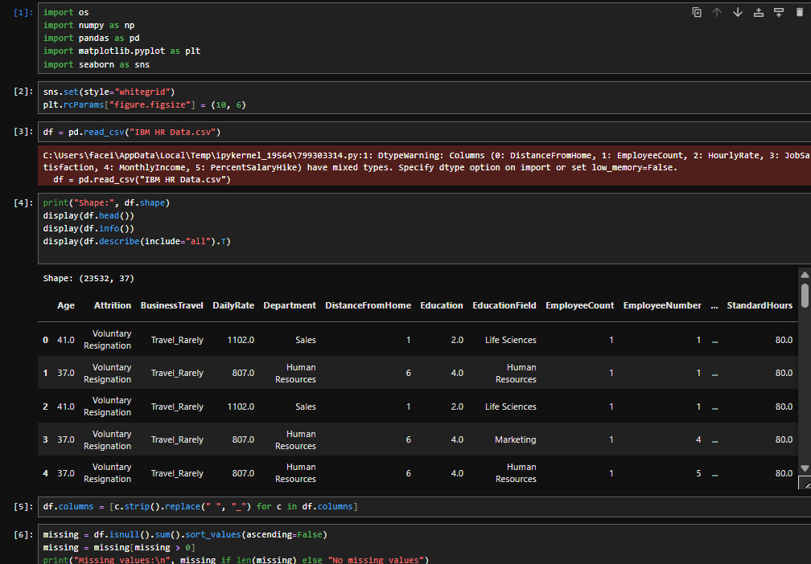
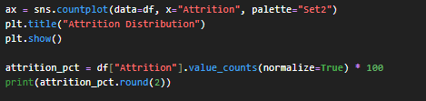
Visualization
Department-wise Attrition
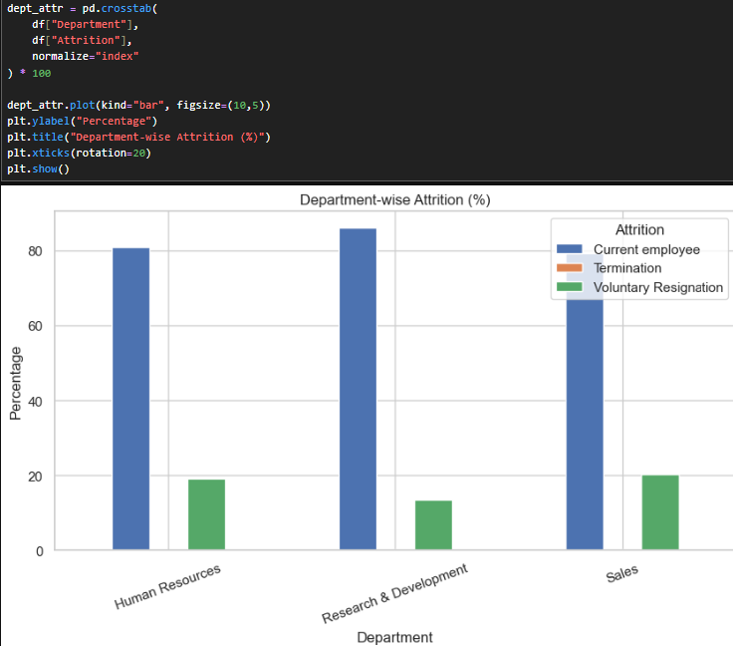
Age Distribution
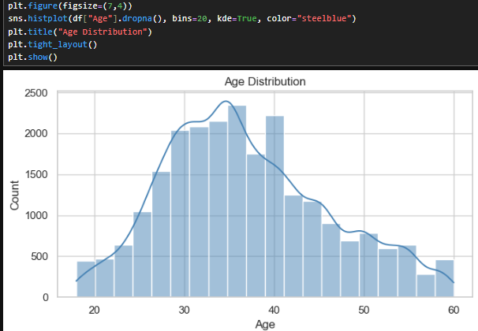
Monthly income by Attrition
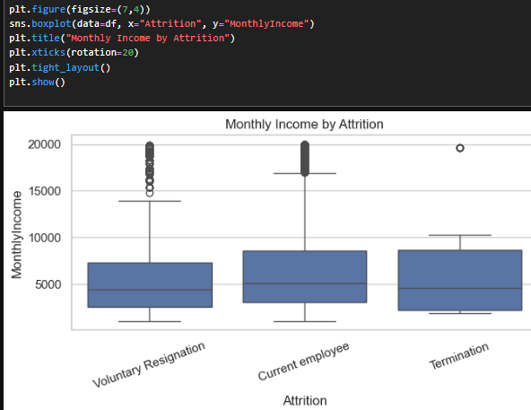
Department wise Attrition
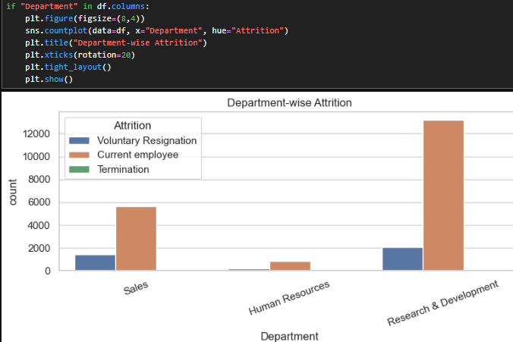
Gender wise Attrition
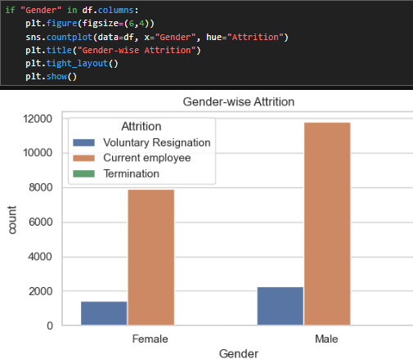
Job involvement by Attrition
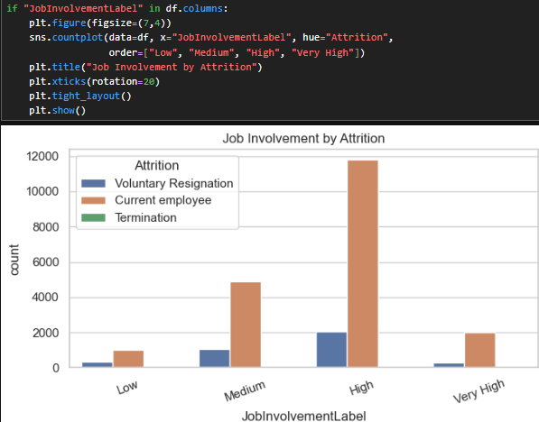
Work Life Balance by Attrition
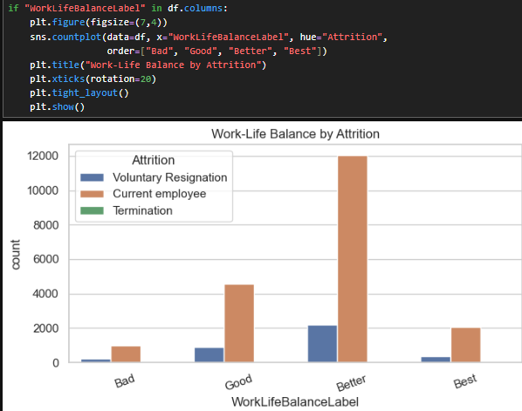
Education Field by Attrition
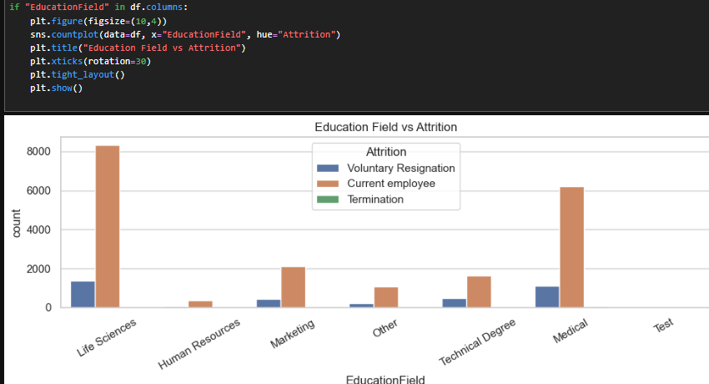
Correlation heatmap
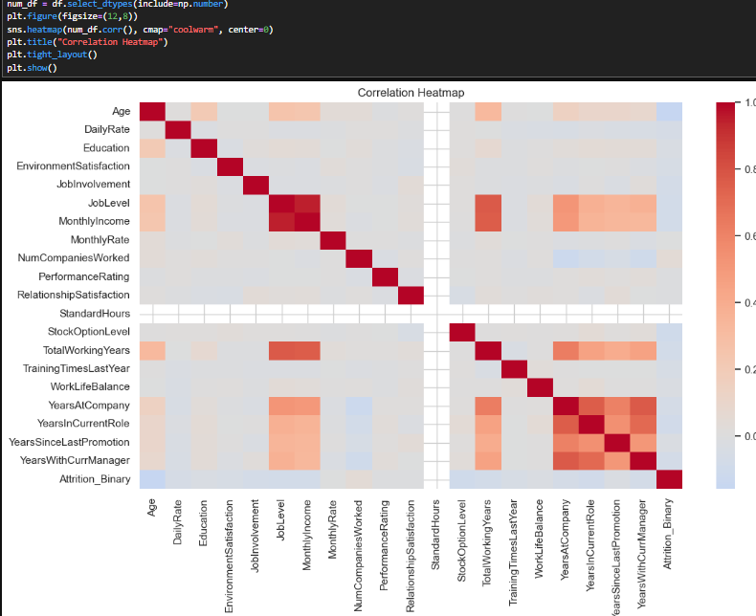
SQL Work
1) Average monthly income by attrition group
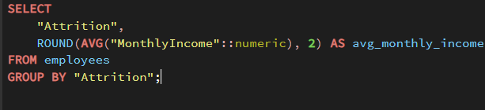
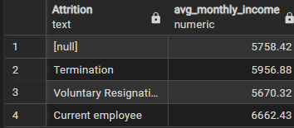
2) Attrition rate

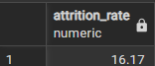
3) Average monthly income for employees who left vs stayed
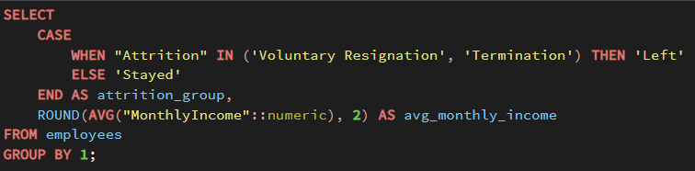
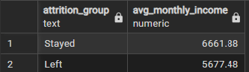
4) Count of employees by attrition label
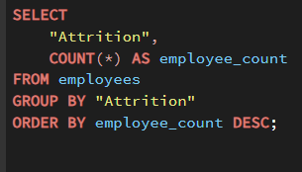
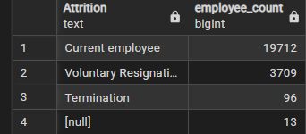
5) Attrition rate by department
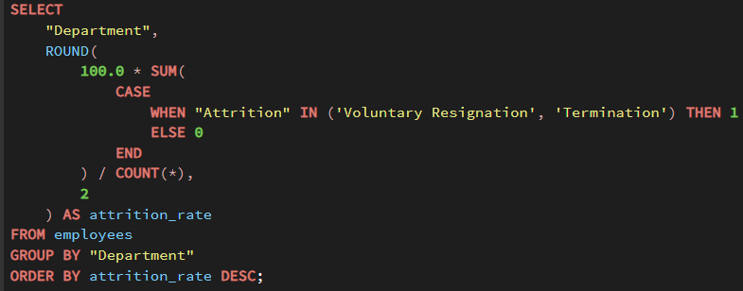
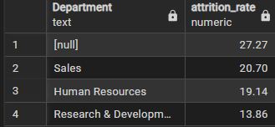
6) Average income by department and attrition group
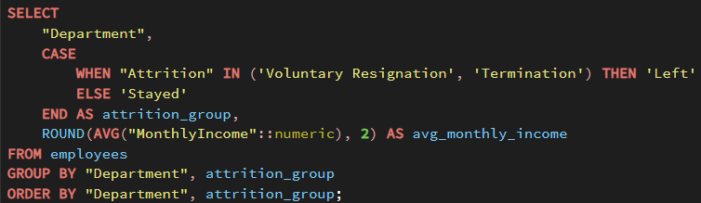
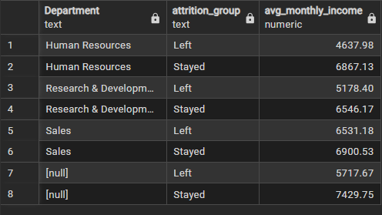
7) Number of employees who left by job role
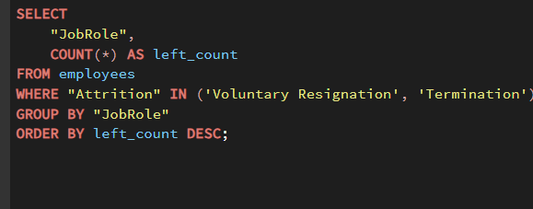
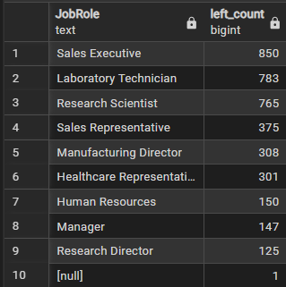
8) Attrition rate by gender
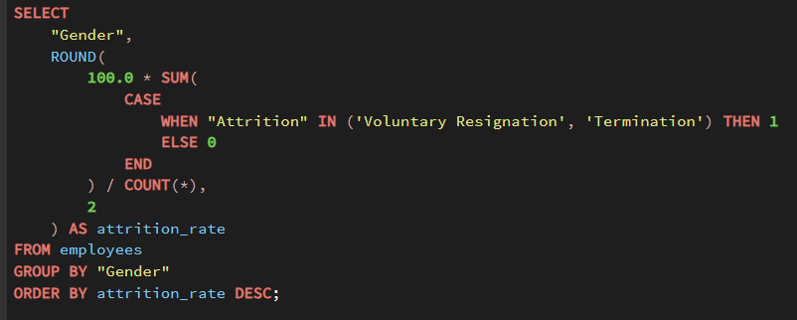
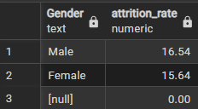
- In the SQL file, the main purpose is to answer business questions such as overall attrition, attrition by department, attrition by job role, overtime impact, and salary impact. SQL is useful because it quickly summarizes large groups of rows and makes the analysis easy to verify. A well-structured SQL script usually includes SELECT, WHERE, GROUP BY, and CASE statements to create useful HR insights

Dashboard using PowerBI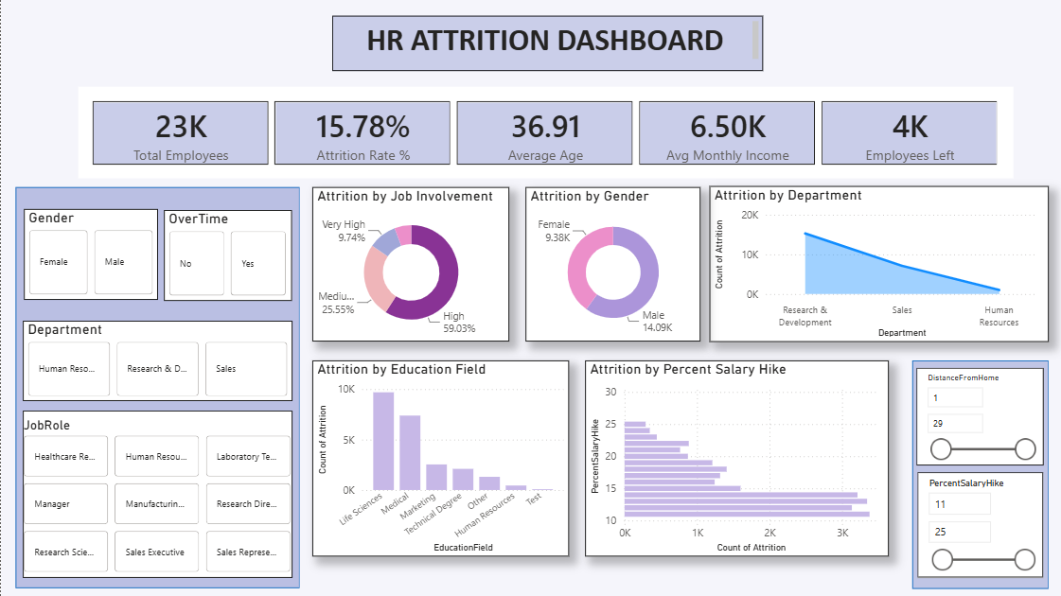
Main Findings
From the above dashboard, we can say that the attrition is not evenly distributed among all the groups. It seems that certain fields such as Department, Job Involvement, Work Life Balance seem to be more significant than other fields but at the moment.
Problems Found
The most significant issue is that the numbers represented in the dashboard are much larger than those expected from the IBM HR dataset. Such a problem is typically a result of duplication of rows in the database and the use of the wrong count method, which should be distinct rather than just the usual one. Another concern is that certain scale-based attributes are represented as numbers.
Fixes Applied or Needed
- Remove duplicate rows in Python.
- Use EmployeeNumber as the unique key.
- Create label columns for JobInvolvement and WorkLifeBalance.
- Use bar charts for category comparisons.
- Use distinct count in Power BI for employee totals.
Conclusion
This project would serve well as an end-to-end HR analytics portfolio project since it involves data cleaning, SQL analysis, and story telling on dashboards. After doing the data cleaning and fixing the chart fields, it will be much more accurate and professional when presenting the report. This way, the project can be showcased as a data analysis case study using Python, SQL, and Power BI.

